Below is information on the ad-hoc drop-box functionality:

If using a regular FTP client, like FileZilla or WS_FTP_Pro, you will need to use the following;

server address = ftp.wi.gov
path = /DOA/shared/publishing
username = submit-print-job
password = any valid email address

Alternatively, you can submit files using the following web page

http://ftp.wi.gov/DOA/shared/publishing

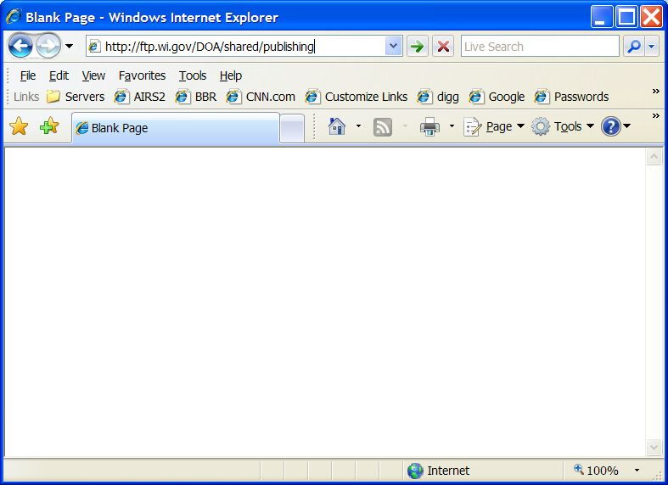

When you to go to http://ftp.wi.gov/DOA/shared/publishing a password pop-up window will appear where you will need to use "submit-print-job" as the username and your email address as the password.

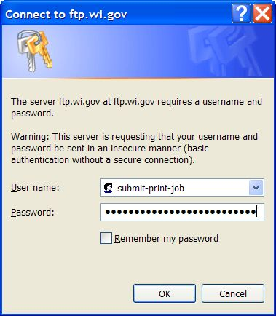

After successfully authenticating, you will see:

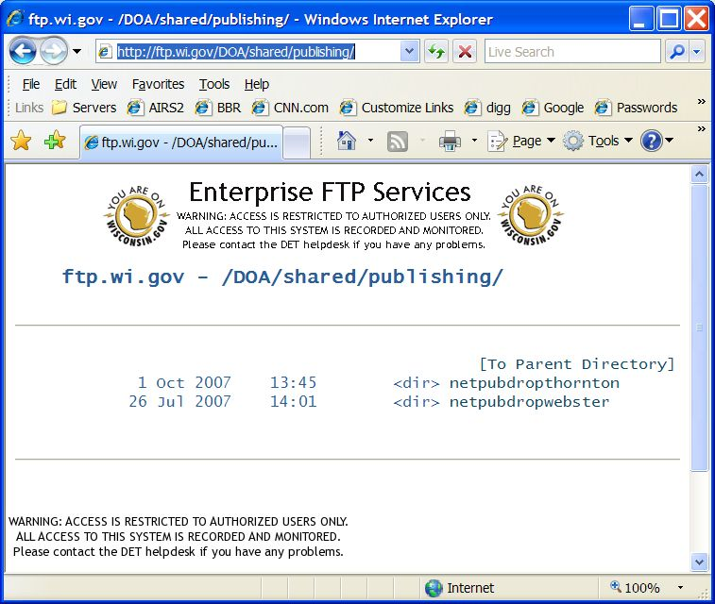

From here, you can go to the appropriate drop-box to upload files. Here is an example of what the Thornton drop-box looks like:
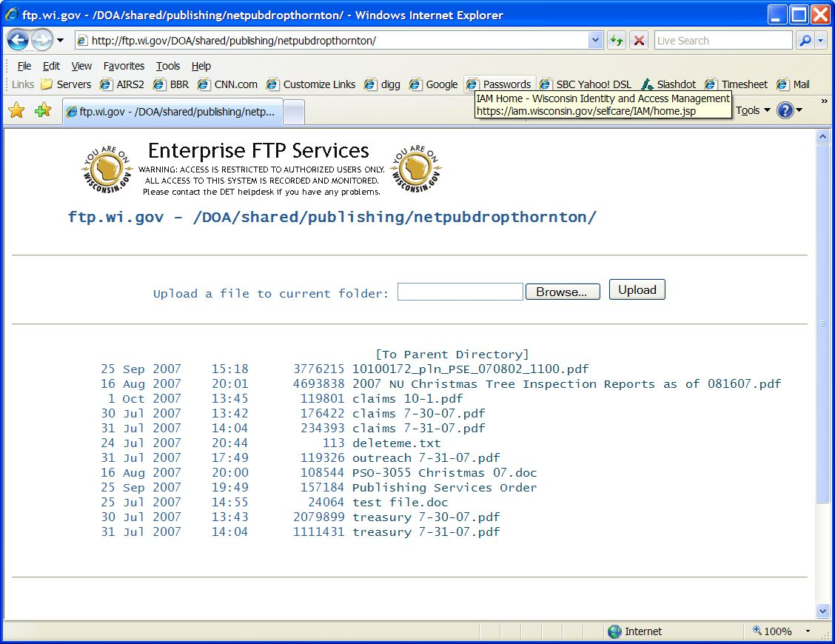

The functionality of the drop boxes is upload only. If you attempt to view any of the files, you will get a "permission denied" error. You can upload a single file at a time, by using the browse/upload buttons at the top of the page.

--

